It’s a Sign!

The Sabbath observance was given as a sign. But a sign of what? Look at the symbols below and read the cited Scripture passages. Try to summarize what each passage says about the meaning of the Sabbath and how it relates to each symbol.

Exodus 31:13, 14; 1 Peter 1:14-16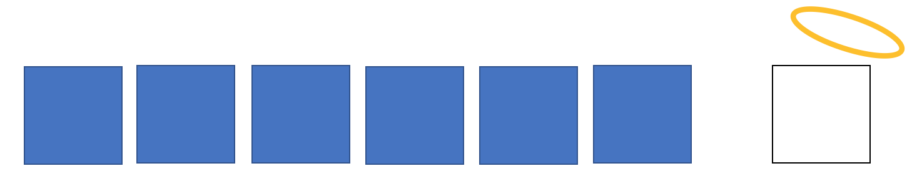

Exodus 31:16

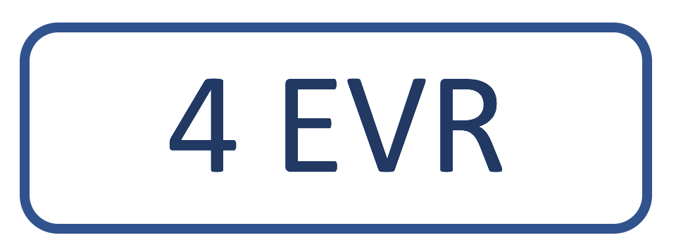

Exodus 31:17, 18; Mark 2:27

